DRAFT MINUTES
AL-ANON INFORMATION SERVICES-CALGARY
Church of Our Savior, 8831 Fairmont Drive, SE Calgary, AB
Sept 12, 2022, ZOOM platform

Attendees: Ally C., Cathy S., Carolyn M., Shellie O., Sherry L., David P., Gina G., Anne C., Svetlana, Rachelle S., Connie Y., Jamie C.

Meeting opened at 7:02 pm with Serenity Prayer
Attendance: 3 non-voting members/ 9 voting members
Concept 6 read by Connie Y. from
Additions to Agenda: Anne to comment on monitoring
Adoption of June 6, 2022, minutes: Moved by Shellie O. and seconded by Svetlana to accept the minutes as presented.

Reports:

- AIS Chair report: (Carolyn M.) Carolyn responded to the query about a survey on Calgary Al-anon and our addictions program. Carolyn declined to be involved since that is not our mandate. Lots of email messages over the summer for meeting information. Carolyn found it very easy to refer them to the websites, Alanon.ab.ca, Al-anon.org and our Big Sky number to have a member contact them. Many people are interested in on-line meetings, so it is nice that we have that option for them. Carolyn received a few AFGs information changes which she passed along. Recovery Day is organized and is this Saturday Sept 17 at a location that is easily accessible to many people. There is lots of handouts and a few volunteers to help out. Carolyn emailed to AHS about support services resuming, but has not been contacted back. Carolyn also filled out the annual form for AHS Access Mental Health with our contact information.

- Treasurer Report: (David P.) David went over our account in detail with the group. It was noted that our donations coming in are less than the money going out for our fees. Our prudent reserve is $1500. Big Sky had an increase, but has chosen not to increase our fees at this time. The newsletter provided acknowledgements to groups for donations and was well received. AIS decided that twice a year we will acknowledge our group donations and support. David also mails out a personal thank you for each group donation. David brought up that possibly we could put a blurb into the newsletter as to what the money AIS receives in donations is spent on. Decided this is a good idea and it will be in the next newsletter.
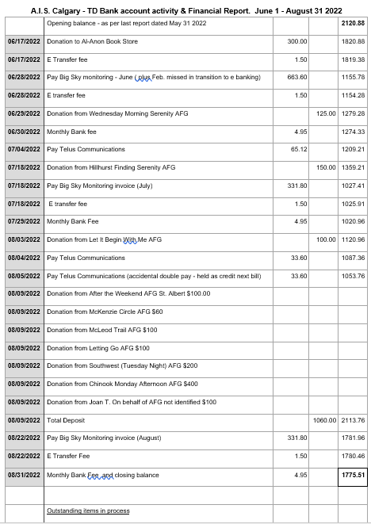

- Secretary Report: (Gina G.) The minutes sent out directly after the last meeting were received by all and no issues with her last emails. Gina is requesting RSVPs for the meetings, so that we know who can and cannot attend.

- Public Outreach (vacant) Carolyn announced that we still do not have this position filled. A plea and job description (it can be a lot of fun) will go into the next newsletter. Please reach out within your groups for a volunteer.

- Newsletter: (Ally C.). Any inclusions for newsletter are to be submitted to aiscalgarynewsletter@gmail.com Deadline for the next newsletter is Friday, Sept 16. Newsletter will be out the following week. Ally is enjoying her role and has received positive feedback on a job well done.

Alateen: (Rachelle S.) The Alateen email is not accessible. Rachelle has reached out for assistance to get it working. Last week Rachelle and committee were revising the safety guidelines. WSO is wanting a conflict resolution document. Manitoba has had theirs approved so Rachelle has been using some of their work to help create one for Alberta. Our Area Delegate Diane G. was able to talk with some of the people at WSO to help move our process along. AMEIAS (Al-Anon member Involved in Alateen Service) are to be recertified every year by June 15. This did not happen a while ago and this is why Alberta lost its certification. We are now the only Area without it. Rachelle and her committee are hoping that Alberta will have certification within the next 2 months. Rachelle has a list of previous AMEIAs and will be contacting them to be certified. If anyone knows of anyone interested in being an AMEIA, please forward their name to the Alateen email AIScalgaryAlateen@gmail.com or Gina at calgarysecretary@al-anon.ab.ca and she will forward to Rachelle.

- Monitoring: (Shellie O.)
May June July
Calls to Big Sky 102 72 70
Taken by volunteer 85 57 54
Abandoned 17 15 17
Member returned a call 62 37 29
Anne brought up a situation, from a member, who dealt with a caller, who was in distress, suicidal and in an abusive home. Discussion followed as to how we should handle these situations. Decision is that this is a very rare occurrence and the volunteer handled themselves very well and did offer support and provided the Suicide Hotline number. Illustrates how the Al-anon program provides guidance in all parts of our lives. Kudos to this member. In 2023, 988, the Distress/mental health phoneline will be in place.

- Webpage Liaison (Cathy S.) Draft minutes from June’s AIS meeting are on the website, and this meetings minutes will go on soon as well. Reminder to have the document review on the November agenda.

- Round-up – (Anne C/Carolyn M) The event went very well. Lots of people came to the book table. We had bookmarks to give away and we sold quite a few books. The Workshop, Cleopatra is not the only Queen of denial, was attended by our own members in attendance. Unfortunately, our workshop coincided with an AA speaker, so we didn’t get any others attending. We were able to provide Diane G. our area delegate, who resides in Edmonton, to be the Al-anon speaker. She was well received. Carolyn mentioned that we are to be invited to the debriefing meeting and hopefully will be included in planning for the next years Round-up from the beginning. We would like to be involved with getting the Al-anon speakers, and would prefer they come from Western Canada. Side note: our area list of qualified speakers needs to be updated. Anyone interested please contact aiscalgaryinformation@gmail.com.
Banff Round Up 2023 (Jamie C.) Looking for an Al-anon speaker for this event in 2023 and some input as to what we would like to provide at this event. The timing will be about 90 minutes for the speaker and we can also have another event. Any ideas contact Jamie.
The Pioneer dinner on October 15 has the same Planning committee as the Banff Roundup and they are great to be working with. Carolyn M has agreed to speak at the pioneer dinner. A poster has been created and will be placed into the Newsletter and emailed out to the groups to share with their members. The date is Oct 15 from 1-7 pm. Tickets are $35.

- General discussion

Next meeting November 7, 2022 – Zoom ID 471 384 6072 Passcode 987654
Gina G volunteered to read concept 7 at November meeting.
Meeting closed at 8:09 pm.
Submitted by:
Gina G.
Calgary AIS Secretar

