Approved Minutes
AL-ANON INFORMATION SERVICES-CALGARY
Church of Our Savior, 8831 Fairmont Drive, SE Calgary, AB
June 6, 2022, ZOOM platform

Attendees: Sally K., Ally C., Cathy S., Carolyn M., Carol G., Gina G., Anne C., Svetlana, Connie Y.

Meeting opened at 7:08 pm with Serenity Prayer
Attendance: 3 non-voting members/6 voting members
Concept 5 read by Anne C. from “Reaching for Personal Freedom”:
Additions to Agenda: Discuss email received from City of Calgary, mental health and addiction, for answers to a survey.
Sally K announced that she has been appointed as the Regional Trustee for Canada West in Al-Anon. She must resign as alternate chair as she cannot hold a position above the Group Level while in this position.
Adoption of April 4, 2022, minutes: Moved by Anne and seconded by Alley C. to accept the minutes as presented.

Reports:

- AIS Chair report: (Carolyn M.) Carolyn recently attended the Area World Service Committee Meeting. It was a lengthy meeting. (Meeting details document provided)
Most of the work supporting the aiscalgaryinformation@gmail.com and “calgaryaischairperson@al-anon.ab.ca is directing individuals to meeting list access as well as the help line for Calgary. I did receive one query as to whether a family could bring their actively drinking alcoholic to an Al-Anon meeting. Also, one query to participate in a survey.
I attended Area Assembly and AWSCM meeting May 28, 29, 2022. Highlights:
1. 84 attending, 52 voting members
2. The Area 80 Public Outreach Coordinator position was filled: Karen Birnie is our current coordinator.
3. Last names were agreed to use during assembly as there are several coordinators and officers with the same name.
4. Area Treasurer:
E-transfers to treasurer@al-anon.ab.ca ensuring that the security answer is always: “serenity”. Please include the group name and WSO number in the comments to help Donna identify which groups need receipts. Receipts will be handed out as Assembly when next in person.
Mailing address:
Donna Hogan
335-369 Rocky Vista Park, NW
Calgary, AB T3G 5K7
Protect her anonymity when using regular mail.
Note: 85% of registrations are done through e-transfer.
5. Venue report: many challenges were noted when investigating possible venues. Therefore, it was decided that September 2022 Assembly will continue with ZOOM format and plans will be made for in person Assembly for 2023.
6. Budget report: no changes for 2022 (COVID budget) but changes will have to be made for in person 2023 Assembly.
7. ACSOA: a member has volunteered to be treasurer for ACSOA. Price increases will be coming in the fall. Again, e-transfers are appreciated.
8. Group Records:
Please email all group information changes to: grouprecords@al-anon.ab.ca
Line of communication for changes: group to Area to WSO
If group has questions: 1-780-967-3356
9. Discussion around removing password protection to the website access to the meeting list.
10. Delegate report: new area invited. Area 98 will be the Global Electronic Area, servicing permanent electronic groups (PEG). Area 80 will accept any permanent electronic meetings within our geographic area to be part of Area 80 support. Alateen certification process has affected 11 Areas. 98 Alateen meetings were decertified. Work is ongoing as to how to best support Alateen. The new regional trustee: Sally Kotchorek. The service manual will need revision to accommodate electronic meeting guidelines. Upcoming: literature review to acknowledge the LGBTQ community and address neutral language.
11. Public Outreach Task Force: recommend creation of public outreach committee. Increased use of social media will be examined in relation to public outreach activities.
12. Electronic Meeting Task Force: met the task requirements set out by Assembly. As September Assembly, a new task force will be formed to outline how Area 80 will respond to the needs of electronic meetings in our area.
13. Districts 21/8 and 6 volunteered to make “love gifts” for the Area Delegate’s next visit to WSO Conference.
14. District volunteer needed to host 2023 Area Convention.
AWSCM May 29, 2023
1. A new Task Force will be formed to address how Area 80 moves forward to support permanent electronic meetings.
2. Voted to remove the password protection from Area website meeting list. Carried.

- Treasurer Report: (David P absent) Carolyn discussed the reports he provided by email. A Telus bill is not showing on these reports, but Carolyn recalls signing for one. It appears we have extra monies and possibly need to discuss donations to our service arms, ACSOA and possibly the book store? Discussion, and Anne motioned to donate $300 to ACSOA, Connie seconded, Vote passed unanimously.
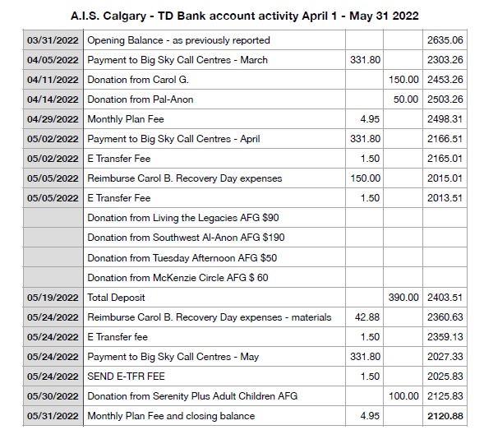

- 3. Secretary Report: (Gina G.) The minutes sent out directly after the last meeting were received by all. The last email with the agenda for this meeting and cop of draft minutes was rejected by most of the Gmail accounts on file. Documents from the Treasurer were sent out separately and Gina did not have a notification of any rejections. Possibly Gina will need to look at using Mail Chimp or sending smaller email groupings to avoid GMAIL thinking it is SPAM. Providing Gina with your phone number or an alternate email (not Gmail) would give the Secretary another option to contact those whose email was rejected. If you would like to provide an alternate, please email calgarysecretary@al-anon.ab.ca. It will only be used for this purpose. AIS minutes will be also be uploaded the AIS website (al-anon.ab.ca) for everyone to see.

- Public Outreach (vacant) Carolyn announced that we do not have this position filled. We need someone to step into this role as to run our booth at Recovery Days in September. It also has some involvement with AHS and their addiction programs. We will be sending out a separate email regarding this position. Please share the message.

- Newsletter: (Ally C.). Send any inclusions for newsletter to aiscalgarynewsletter@gmail.com Deadline for the next newsletter is Friday, June 10th. Extra bulletins for Public Outreach, Alternate AIS Chair will go into newsletter and possibly a separate mailing. Ally asking Cathy S for a little guidance with some technical issues.

- Alateen: (Rachelle S. absent) Calgary Alateen does still not have authorization, but the people continue to work with WSO for approval. 98 groups were decertified so Alberta is not alone. Looking for solutions. Refer people to Alanon.org for electronic meetings and chat.

- Monitoring: (Shellie O. absent) April we had 106 calls and May 102. This is up from February and March numbers.

- Webpage Liaison (Cathy S.) Would like a strategic plan for reviewing the documents on the AIS website. Last date is 2019. We can put on Agenda to review in November. The minutes from AIS meetings to be on the Alanon.ab.ca webpage.

Carolyn mentioned that at weekend conference she spoke with the Edmonton AIS chair. Some discussion about possibly having a meeting to with them to see if we can learn from each other.
General discussion
Districts 3 and 4 are willing to support district 5 while they struggle with lack of volunteers.
Group Records – The group meeting lists are the responsibility of the Secretary. During COVID meeting lists were prepared, updated and kept current by the Public Outreach coordinator. The traditional roles will revert back. A current Group list is required by AIS to support the monitoring coordinator and Big Sky. Changes to meetings should be emailed to grouprecords@al-anon.ab.ca and CC to calgarysecretary@al-anon.ab.ca. Groups records informs WSO of any changes.
Banff Roundup/Gratitude liaison position is also available. Anne and Carolyn have been working on this weekend’s Roundup, but we really need a liaison to take on this role. Carol G commented that there is a job description with instructions which makes the job run smoothly.
What are the challenges with having this position filled? How can we support the volunteer? Any suggestions, ideas would be welcome. aisinformation@al-anon.ab.ca
City of Calgary email – asking for a male opinion on how good mental health supports addictions. Questions are is this the right group to survey. Al-anon members are to support addicts. Decided to ask a few questions to writer of email at City and then determine if it should be forwarded to the men’s Group.
Connie Y volunteered to read concept 6 at September meeting.

Next meeting September12, 2022 – Zoom ID 471 384 6072 Passcode 987654
Connie volunteered to read Concept 6 at the next meeting.

Meeting dates 2022: November 7
Meeting closed at 8:21 pm.
Submitted by:
Gina G.
Calgary AIS Secretary

