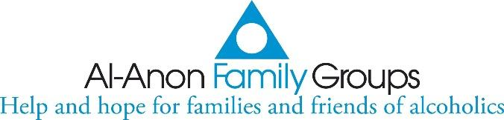

**AL-ANON INFORMATION SERVICE (AIS) EDMONTON**

**TELEPHONE ANSWERING SERVICE (TAS) ROSTER**

**August 27 – November 25, 2023**

|  |  |
| --- | --- |
| **Groups** | **Coverage Dates** |
| Circle of Hope (Sherwood Park) | August 27 – September 2 |
| Fort Saskatchewan | September 3 – 9 |
| Gold Bar | September 10 – 16 |
| Oasis | September 17 – 23 |
| St. Albert Tuesday Night | September 24 – 30 |
| Strength and Hope (Sherwood Park) | October 1 – 7 |
| You Count | October 8 - 14 |
| Reaching Out | October 15 - 21 |
| After the Weekend (St. Albert) | October 22 - 28 |
| Friendship AFG | October 29 – November 4 |
| Before the Weekend (St. Albert) | November 5 - 11 |
| One Day at a Time (St. Albert) | November 12 – 18 |
| Step by Step | November 19 - 25 |

**Upon roster expiration, please shred the list.**

**Any questions, concerns, suggestions, feedback,**

**please contact the AIS Edmonton TAS Coordinator,**

**John Hearn,** [**sahgrep@gmail.com**](mailto:sahgrep@gmail.com)**780-860-7284**

**IF YOUR CONCERN IS TIME SENSITIVE– PLEASE PHONE**

**Thank you for your continuing gift of service!**