OASIS AL-ANON FAMILY GROUP

We will be celebrating our 20th Anniversary on Saturday May 11

Please join us at 0930 for potluck and coffee

Meeting, with Speakers, will be from 1000 – 1100

Fellowship continues until 12
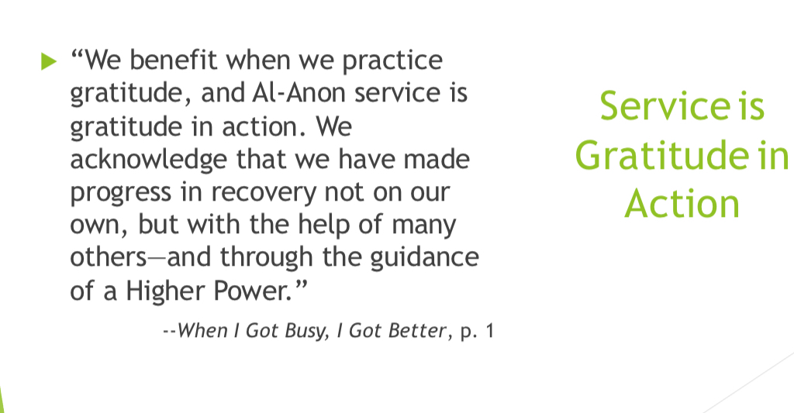
St.Peters Anglican Church Hall 11035 127 St NW

