DRAFT MINUTES
AL-ANON INFORMATION SERVICES-CALGARY
Nov 4 , 2024, Hybrid

Attendees: Carolyn, Gina, Ian, Sherri, Anne, Shellie, Jamie, David, Gary, Colleen, Randy, Karen, Kate, Carol, Linda, Candace, Joanne,
Meeting opened at 7:00 pm with Serenity Prayer
Attendance: 6 non-voting members/ 11 voting members
Concept 5 read by Carolyn and Anne
Carol moved to adopt minutes from Sept 2024 with change of June to Sept in title. Seconded by Sherri. Motion carried.
Reports:
AIS Chair Report: (Carolyn M) I attended the assembly in October and was not really required to participate as outgoing Chair. It was a success. I have had an email from someone who attended the newcomers meeting at PLC and no one else was in attendance. This is the second email in a short while about no support at this meeting. I will be reaching out to the districts hosting this meeting. Most emails have been nice to reply to as it is usually people seeking more information and I direct them to our websites. I have enjoyed this position.
Meeting dates for the upcoming year are Feb 3, 2025; Apr 7, 2025; June 2, 2025; Sept 8, 2025. February 3 meeting will only be on Zoom, all others will be hybrid.
- Treasurer Report: (David P.) Question raised about Telus mobility payee –> new name for Telus billing. Last month we voted to bring our bank balance in line with our prudent reserve. The following donations were sent; $1000.00 to the ACSOA, $250.00 to WSO and $250 to Area 80 assembly. . Also, we voted for AIS to donate $1500.00 towards the Area 80 2025 convention, that Calgary is hosting. This money was sent to a wrong email, so was redeposited and sent to the correct address. Currently we have $250 dollars on hold for Alateen. The proposed 2025 budget is attached as well, we will vote in February. Sherri motioned to accept the report and Gina seconded. Approved.

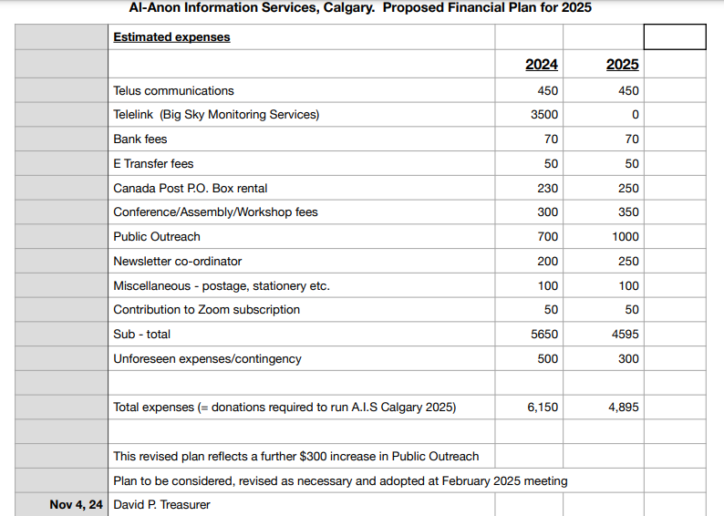
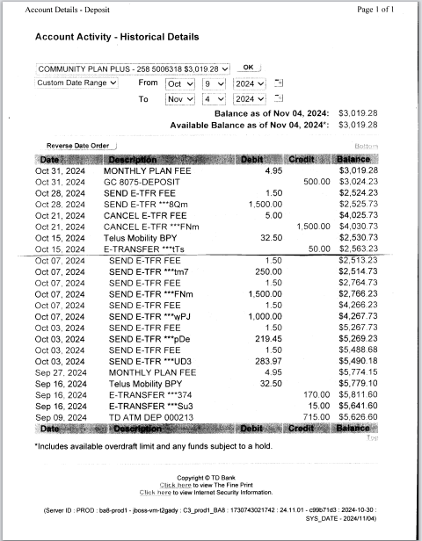

- Secretary Report: (Gina G) Please forward all new AIS/Alternate Reps name and email to Gina so that she can update the records for future meetings. The email was moved to a different server and some glitches happened with contact lists. If you did not receive an email, please let Gina know.
- Public Outreach: (Raman G and Anne C) Recovery Day went well. A 10 x 10 sunshade structure was purchased for weather protection, so we were covered during the rain. Snacks that we gave out were a success, as were the pamphlets we gave out. We held an Al-Anon meeting (step 1) on October 10 for the family and friends’ group at Fresh start. About 60-80 people attended and we were on a stage. The director spoke and there was also a dinner. The director is keen to work with us. We are meeting on Thursday with Tsu Tina child and family services. Their director is interested in an Al-Anon meeting being started on the reserve. Currently they have a successful AA meeting. They have a high number of 18-year-olds that return to the reserve after being in foster care, and a lot of elder abuse. Al-Anon could be a good resource. They are willing to support the meeting, provide a meeting room and are looking for some help organizing. Carolyn noted that this is not the first attempt for them to start a meeting, and they need their people to commit. Perhaps WSO can be of help because there are other groups on reserves that could be a great resource for success. We can do our best to help. Anyone interested in using the sunshade for events, we are willing to lend it out. We also ask for groups to donate (old) pamphlets to us for distribution.
- Newsletter: (Kate L) Deadline for the next edition is Nov 8, 2024. Email is aiscalgarynewsletter@gmail.com. Please submit your information by late Friday. There will be a news bulletin in December as well. Deadline for submission to newsletter is always in the week of the AIS meeting. Sending a reminder email out to groups could be helpful with submissions.
- Alateen: (vacant). Tuesday, Nov 12 is their first meeting. Currently we do not have a chair, but we do know a few of the AMIAS, so hopefully they can submit a report for us at next meeting.
- Monitoring: (Shellie/Randy) – Randy has taken over as chair. We had a meeting, and he is well prepared. Randy contacted Telus and requires a pin# or Access # to make changes. They offered another solution that may be helpful, and he will be talking with them soon. He has access to the email and has been working to clean it up. He will be contacting groups regarding monitoring as some do not volunteer, some are on the schedule more often and some do not provide volunteers on their scheduled week. The calls coming in are on the website can be tracked and we are not getting too many voicemails to respond to. Only a few per week.
- Banff Round up: (Jamie C) Jamie will remain in this position for this year. If anyone wants to learn the role, she can certainly share her experience. This position also includes the Pioneer dinner event in October. First planning meeting for the Banff Roundup will be in November 7th. Jamie is taking on the new role of District 4 Rep.
- Gratitude Round up: (Anne C) June 13-15, 2025 weekend is the AA Roundup. They are looking for an Al-Anon speaker recommendations. If anyone is interested in helping, please contact Anne as she would appreciate a co-chair. Alberta/NWT Area convention is the weekend before in Balzac and Calgary is hosting. So busy two weekends of recovery.
- Web site Coordinator : (vacant) We may have an interested person for this position, Natalie, the GR from Tuesday/Saturday Mckenzie Circle group.

General discussion: Elections and transfers are as follows, Thank you everyone for your serice.
Chair – Shellie O.
Alt Chair (possibly Christina N)
Treasurer – David P. will stay on.
Secretary – Gina G. will stay on,
Public Outreach – Raman G. , Anne C. and Catherin M. are staying on,
Newsletter – Kate L. is staying on,
Al-Ateen- vacant,
Monitoring – Randy H.
Banff Round up Liason– Jamie C. is staying on for this year,
Gratitutude Roundup – Anne C. is staying on but would like a co-chair,
Website – (possibly Natalie L.)
Please let people know how important AIS is to Calgary. Signatory will have to change with Carolyn leaving and Shellie stepping in.
Next meeting Feb 3 2025 – HYBRID - Zoom ID 471 384 6072 Passcode 987654
Meeting closed with Al-Anon Declaration at 8:04 pm.
Submitted by: Gina G. Calgary AIS Secretary

