**DRAFT MINUTES**

**AL-ANON INFORMATION SERVICES-CALGARY**

**Sept 9, 2024, Hybrid**

**Attendees:** Carolyn, Gina, Candace, Anne, David, Debbie, Carol, Collette, Colleen, Sherri, Shellie, Randy

Meeting opened at 7:03 pm with Serenity Prayer

Attendance: 4 non-voting members/ 12 voting members

Concept read by Carolyn

Debbie motioned to adopt the Sept 2024 minutes as printed. Sherri seconded. Motion carried.

**Reports:**

**AIS Chair Report:** (Carolyn) Email activity regarding meeting lists has declined. There has been coorespondence with; Public outreach initiatives – I participated in the Area 80 meeting regarding the poster blitz during Recovery Week, and also discussions of future outreach initiatives; Alateen meeting availability and Alateen meeting setup in Calgary. I have reviewed my job description and it is accurate and no changes required. I am stepping down in my role as Chair at the end of the term (Dec 31, 2024) as I have personal responsiblities that have made the workload a little harder. I will gladly be available for transition and act as Alternate Chairperson unless another member would like to assume that role. I have enjoyed this role very much.

The meeting in November was discussed and voted to be a Hybrid meeting. This will give people the opportunity to hand over their thumb drives and any pertinent information to new incoming AIS persons. Available positions are *Chairperson*, *Secretary*, *Treasurer* (David will stay on if nobody steps in), Monitoring Co-ordinator has Randy stepping in unless another person wants to stand for election, Alateen Co-ordinator may have someone interested, Gratitude Roundup Liason would like another person to help as Carolyn is stepping away, AA Banff Coordinator is staying on but would love to have someone shadow for takeover the following year, Website Cooridinator is also available.

Meeting dates for the upcoming year have been set for: Nov 4, 2024; Feb 3, 2025; Apr 7, 2025; June 2, 2025; Sept 8, 2025. February 3 meeting will only be on Zoom, all others will be hybrid.

1. **Treasurer Report:** (David P.) We have more than our prudent reserve currently. Telephone changes have made our costs decrease quite significantly and also our groups have been very generous with donations. Big thank you to all the groups who continue to support AIS.

Discussion ensued regarding how to bring our bank balance in line with our prudent reserve. Ideas included Area 80 Convention 2025 – which Calgary is hosting, the Calgary bookstore (ACSOA) which always can use funding support, and money for the start-up of the new Calgary Alateen meeting.

Currently Area 80 provides $500.00 of seed money to the hosting convention committee to get started preparing for the event. This amount is quite small for placing deposits on hall rentals etc. This money is returned to Area 80 after the convention. Question raised was can we directly donate funds to the Convention committee or do we need to contact Area 80. Carolyn offered to approach the convention committee and Area 80 regarding this. Shellie moved to have AIS donate $1500.00 towards the Area 80 2025 convention, that Calgary is hosting. Anne seconded. Motion passed.

Our current budget did not have a line item for Alateen because we did not need to. In the 2025 budget there will be a line item for Alateen, which AIS will help support. In the meantime, they will need money for this year for start-up costs, rent books, etc. Debbie moved that we give Alateen $500 as a donation this year.

Further discussion continued and Anne moved that we donate $1000.00 to the ACSOA, $250.00 to WSO and $250 to Area 80 assembly. Debbie seconded the motion. Motion passed.

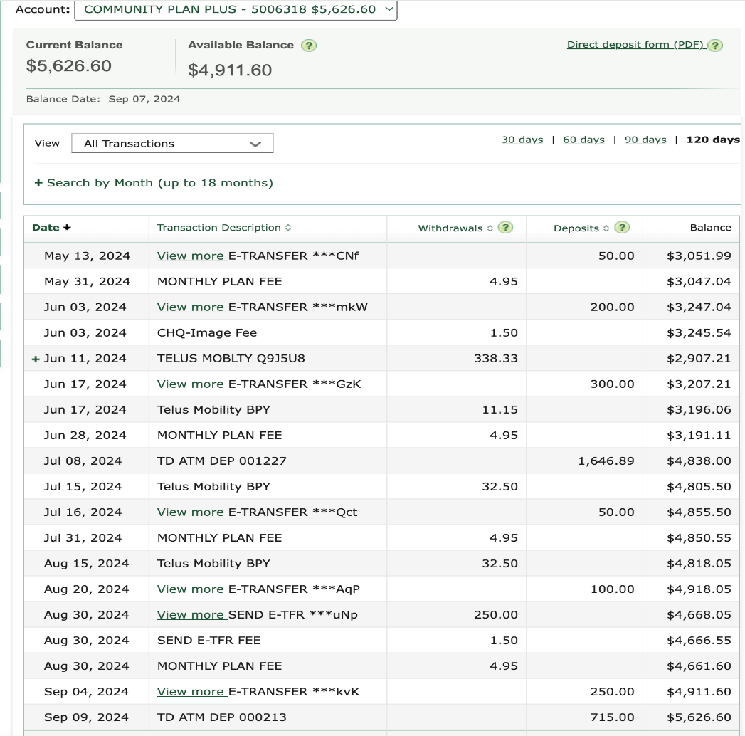

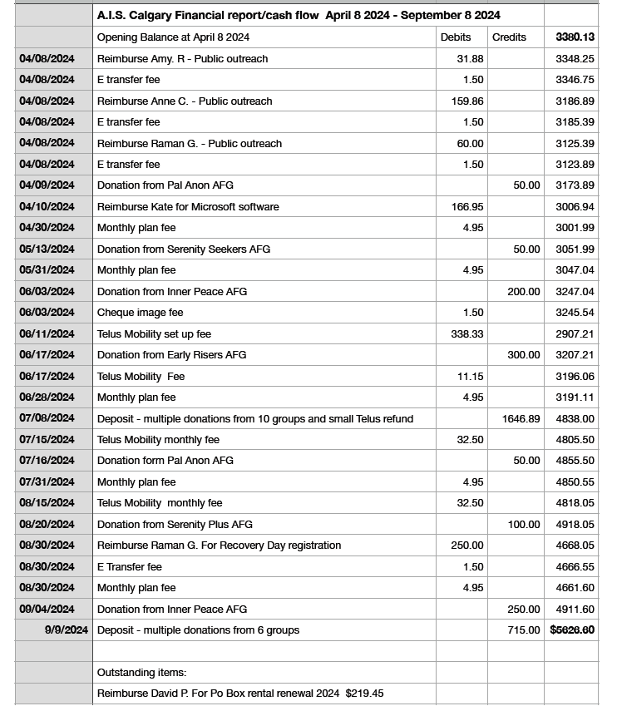

1. **Secretary Report:** (Gina) Please forward all new AIS/Alternate Reps name and email to Gina so that she can update the records for future meetings. Also please ask the current person if they want to continue receiving AIS information. Anyone who is already attending the AIS meetings, this position is quite compatible.
2. **Public Outreach:** (Anne) Raman sends regrets. Recovery is this Saturday at Princes Island from 11-4 pm. Fresh Start is a sponsor of Recovery Day. Please come and join us. There will be speakers throughout the day. We will also offer some food to entice people to the booth. Fresh Start has requested we run an Alanon meeting on October 10 for their family and friends to promote aftercare. Alumni will also attend. We have posters and bookmarks to hand out. The bookmarks have our meeting times.
3. **Newsletter:** (Kate- regrets) Deadline for the next edition is Sept 13, 2024. Email is [aiscalgarynewsletter@gmail.com](mailto:aiscalgarynewsletter@gmail.com). Please submit your information by late Friday.
4. **Alateen:** (vacant). Shellie shared information provided by Michelle (an AMIAS) from their last meeting of AMIAS and teens. The NEW ALATEEN meeting starts on Tuesday nights @ 7:30 pm at McKenzie Towne Church – 7 McKenzie Towne Gate SE, upstairs, starting November 12, 2024. There are an AA and Al-anon meeting held during the same time. There will be a flyer created by a teen and her parent that will be available at assembly Sept 21. District 6 is hosting a workshop on October 19 and Alateen participation is planned. Please share this information with your groups to get the word out!!
5. **Monitoring:** (Shellie) –We receive approximately 5-6 calls a week. The information is getting out because there are newcomers coming to meetings. Volunteers are not getting very many calls. Randy is interested in having this position this next term. We have an app to track information and hopefully Randy will delve deep and find out how it works. Not all groups are participating and summer seems to be a difficult time. A letter will be going out to the District Reps to follow up on this.
6. **Banff Round up:** (Jamie) I love this job and will be remaining in my position for the next term. If anyone wants to learn the role, I can certainly share my experience. This position also includes the Pioneer dinner event in October. First planning meeting for the Banff Roundup will be in November. Oct 5th is the Pioneer Dinner.
7. **Gratitude Round up:** (Anne) June 14-16 AA Roundup event went well. Our speaker, Peter from Saskatchewan was very well attended and had some AA members in tears. The next dates have not been published but probably the 11-13th. Not sure what Alanon participation will be with the Area 80 convention the weekend before.
8. **Web site Coordinator :** (vacant) All job descriptions are to be reviewed and changes handed in for updates.

**General discussion:** Elections and transfers are in November. Please let people know how important AIS is to Calgary. We provide the Newsletter, Alateen, Monitoring/phone, Website and connection with Bookstore, districts and meetings.

**Next meeting Nov 4 2024** – HYBRID - Zoom ID 471 384 6072 Passcode 987654

Meeting closed with Al-Anon Declaration at 8:10 pm.

Submitted by: Gina G. Calgary AIS Secretary