DRAFT MINUTES
AL-ANON INFORMATION SERVICES-CALGARY
February 3, 2025 Electronic meeting

Meeting opened at 7:04 pm with Serenity Prayer
Attendance: 8 non-voting members/ 11 voting members
Groups in attendance: Wednesday Northern Hill Trailblazers, Wednesday Morning Serenity AFG, Tuesday/Saturday Mckenzie Circle AFG, Tuesday Paths to Recovery AFG, Wednesdays Westside Al-anon AFG, Thursday Let It Begin With Me AFG, Saturday Early Risers AFG, Tuesday SouthWest AFG, Wednesday Serenity Seekers AFG, Wednesday Mcleod Trail AFG, Thursday Living the Legacies AFG
Members in attendance: Shellie O., Christina N., Randy H., Collen G., Shannon b., Roxanna, Anne C., Ric Z., Dave C., Linda W., Natalie L., Ian H., Magda, Jamie C., Gina G., Glenna A., Kate L., David P., Karen F.
Concept 6 read by Christina.
Minutes adopted from Nov 2024 with changes on budget totals.
Ric C, Area 80 Public Outreach Coordinator, was at the meeting to explain about the Saturday Electronic meeting, held at 11:00 am that needs support. This meeting was started about 8 years ago for people to log in for Al-Anon information and ask questions about Al-Anon in AB/ N.W.T. Area. To continue this platform, Ric is here to ask our AIS representatives to talk to their groups and see if we can have volunteers on a regular basis to attend. Ideally 2 people would be online for the hour. Sometimes it is busier than other days, maybe 8 or none will log in. Volunteers need to have a good understanding of our program (possibly with 2 or more years in the program). To view the platform, go to www.al-anon.ab.ca then click on meetings. The link for the (Jitsi) is right there. They are changing to Zoom soon. You can go in and have a look at the site anytime. Ric has some current volunteers from the Edmonton area but needs more and possibly a Coordinator. This site should not be under his job, but that is where it landed. To contact Ric to volunteer or for more information his email is public-outreach@al-anon.ab.ca. It was discussed that possibly Districts could take a month of Saturday’s.
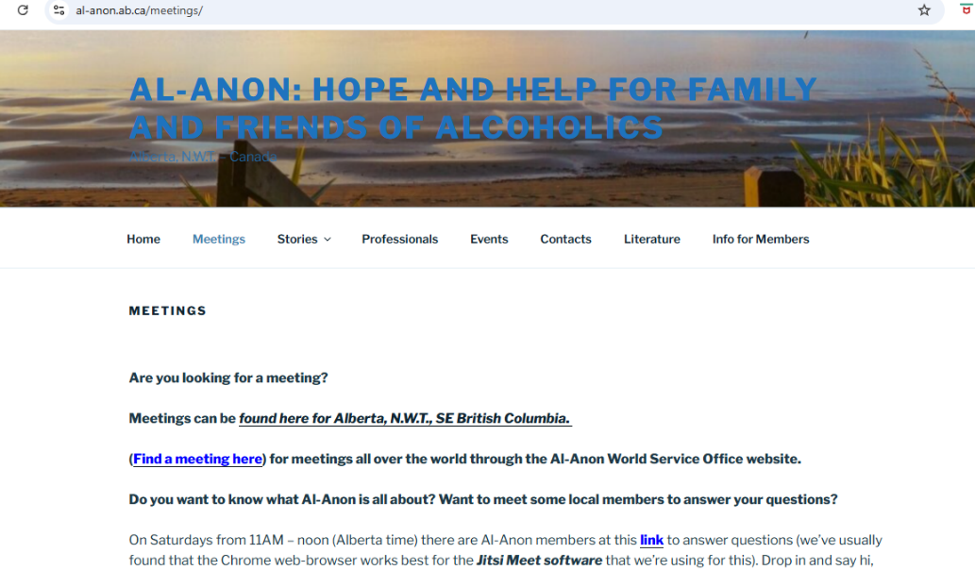
Reports:
AIS Chair Report: (Shellie O) Shellie welcomed everyone and thanked them for coming and was pleased with a great turnout.
Treasurer Report: (David P.) David explained that he and Shellie O. both have access to the bank account. The account is available for electronic banking. The job is not difficult and does not take a lot of time. Treasurer does not have voting rights unless voting for a group. The proposed financial plan, printed in the November minutes, has an error on it, thank you Candace for noticing the mistake. Change made is to remove the fee for telephone expense under subtotal. It now reads 2570. Unforeseen expenses contingency increased from 300 to 500 for a Total of $3070. Glenna motioned to accept the Financial Plan for 2025, Ian Seconded. Motioned passed. Our prudent reserve is between $1500 - 2000. We also have a commitment to support Al-Ateen while it gets up and becomes self-supporting (1000). Reports were not received by everyone and there was some confusion. Apologies from the secretary.

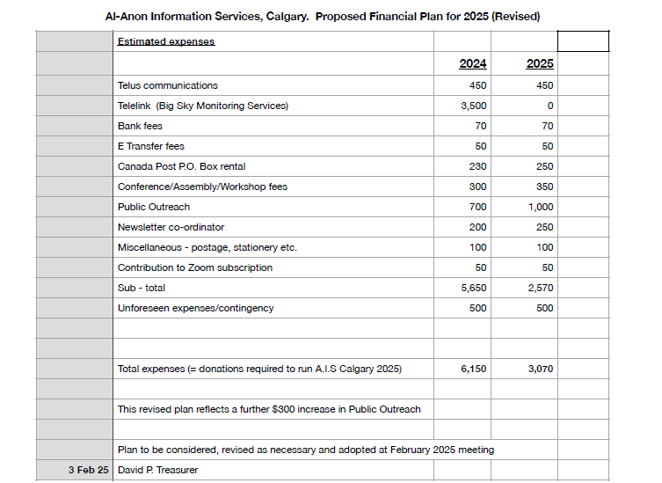

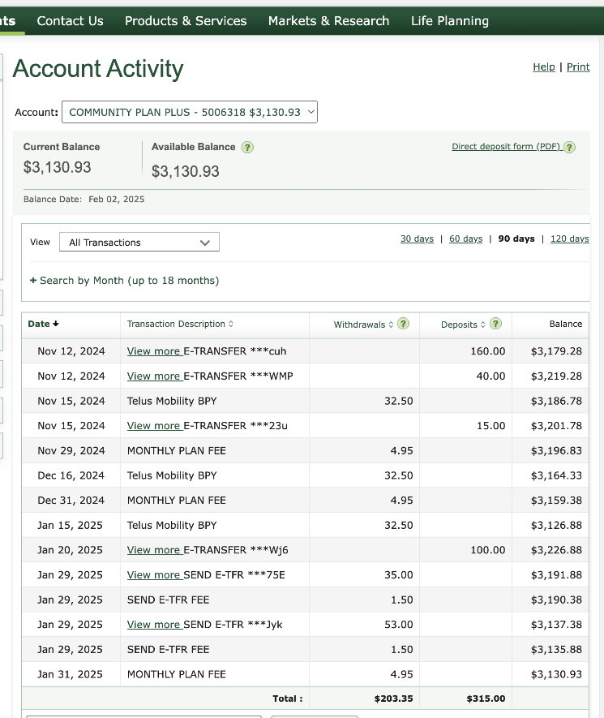
Secretary Report: (Gina G) Please forward all new AIS/Alternate Reps name and email Gina so that she can update the records for future meetings. If you did not receive an email, please let Gina know. A change in webmail required a new list to be made. If you were missed, apologies. All minutes are posted on the Calgary AIS area on the www.al-anon.ab.ca website. When you click on Info For Members it will ask for the password is Area80. Draft minutes are sent out after the meeting and again with the Agenda usually one week before the meeting date. Financials come separately usually a day before the meeting. If you do not receive them, please feel free to email Gina at calgarysecretary@al-anon.ab.ca.
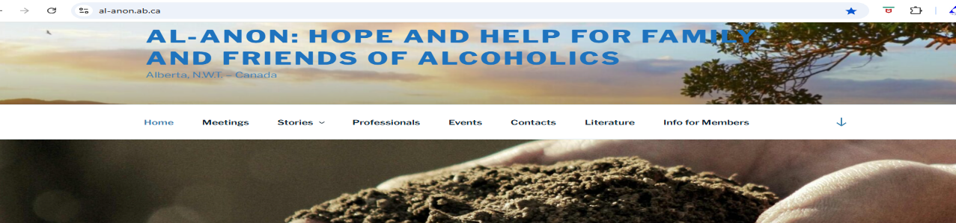
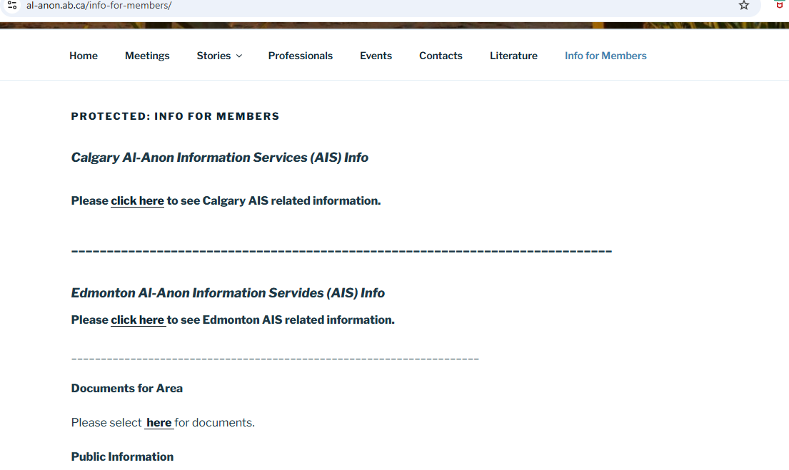
Public Outreach: (Raman G and Anne C) AA group on the reserve asked Public Outreach to help start an Al-anon meeting on the reserve. The Meeting is Wednesday at 5:30 pm. Four AA members have been attending but there has not been much other interest. We have a 6-month commitment. They held an AA Roundup on the reserve which we attended and there was an Al-anon speaker. We hope that the speaker has created some interest.
Newsletter: (Kate L) Deadline for the next Event Bulletin is Feb 5, 2025. Deadline for submissions is always within a few days after our AIS meeting. Please send any posters etc. to me at aiscalgarynewsletter@gmail.com
Alateen: (Shannon B) A meeting is currently running at Mckenzie Towne Church on Tuesday evenings at 7:30 pm. We have lots of AMIAS (Al-Anon member in Alateen service), but some find it is a long travel distance. There are 4-6 kids regularly attending. We are working on a poster and needing the QR code from WSO to add. We are struggling to get the required documents. This group is interested in meeting socially on Friday evening, but there is no group meeting that night. School Counsellors cannot be contacted by Alateen without prior approval from the school board. We have one volunteer who has approached one school board and we are hoping for positive results.
Monitoring: (Randy H) Things are running well. The number of calls varies week to week. It has been challenging to get a hold of some of the Monitoring reps, but it is getting better. I have not had to step in to take a week of calls when nobody has signed up, as Shellie did. I have been able to have replacements.
Banff Round up: (Jamie C.) Round up is Feb 26-Mar 2. There is an Al-Anon meet and greet on Friday night, an Al-Anon workshop on Saturday and an Al-Anon speaker from Nashville on Saturday. Next year the date is changing to April date to avoid travel issues with unpredictable weather. Last year District 4 gave us $300 for food and beverages at the meet and greet. It was very well received. This year we are asking for Calgary AIS to support this or Area AIS since it is in Banff. David said the funds would have to come from Public Outreach, so the conversation would be with Raman and Anne. Gina questioned whether it could be a donation like we make to our service arms, or even Al-Ateen. Tabled for further discussion.
Gratitude Round up: (Anne C and Dave C) June 13-15 is the weekend. The weekend after the Al-Anon AB/NWT Al-Anon convention on June 6-8 in Balzac. Anne has suggested that the turnout of Al-Anon people may be limited due to the event the prior weekend. There have been some difficulties with on-line ticket sales, which they are dealing with. Last year’s Round up did not break even.
Web site Coordinator: (Natalie L) -Natalie has been in and checked the website out. Made a few adjustments to make it look better. Natalie’s personal email address of natalie_lawrence@me.com can be used until she has access to calgary_website@al-anon.ab.ca
General discussion: Next meeting to be hybrid or Zoom only? Discussion was brief, group conscience taken and voted in favour of being only on Zoom in April.
Next meeting April 7, 2025 – Zoom ID 471 384 6072 Passcode 987654
Meeting closed with Al-Anon Declaration at 8:15 pm.
Submitted by: Gina G. Calgary AIS Secretary

